I. Find the value of each of the variables.

6

10

y

y+3

1.

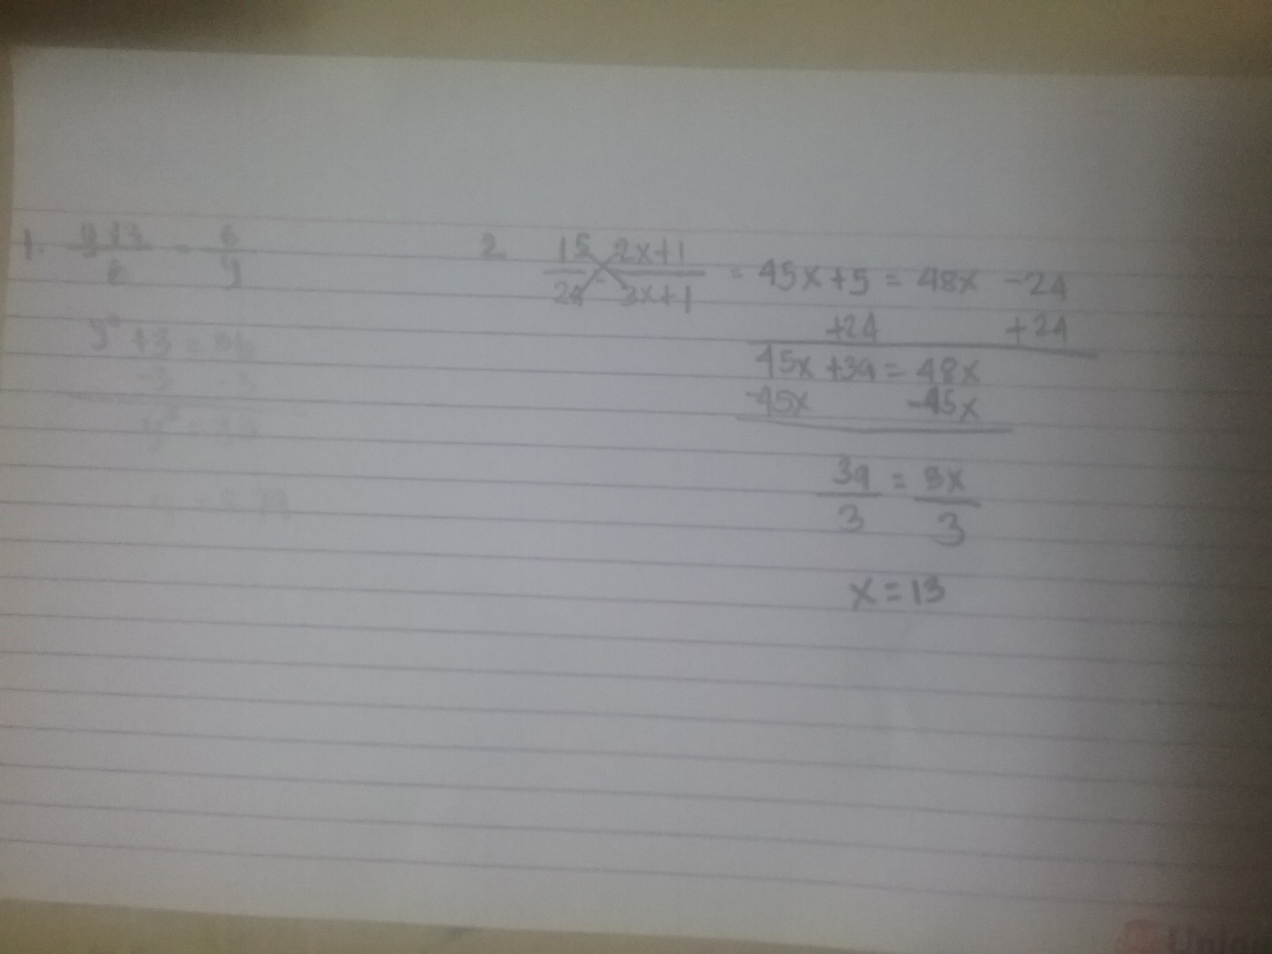

y = 5.74

A

B

E

C

D

15

24

2x-1

3x+1

2.



x = 13

3.

1

4

c

b

a

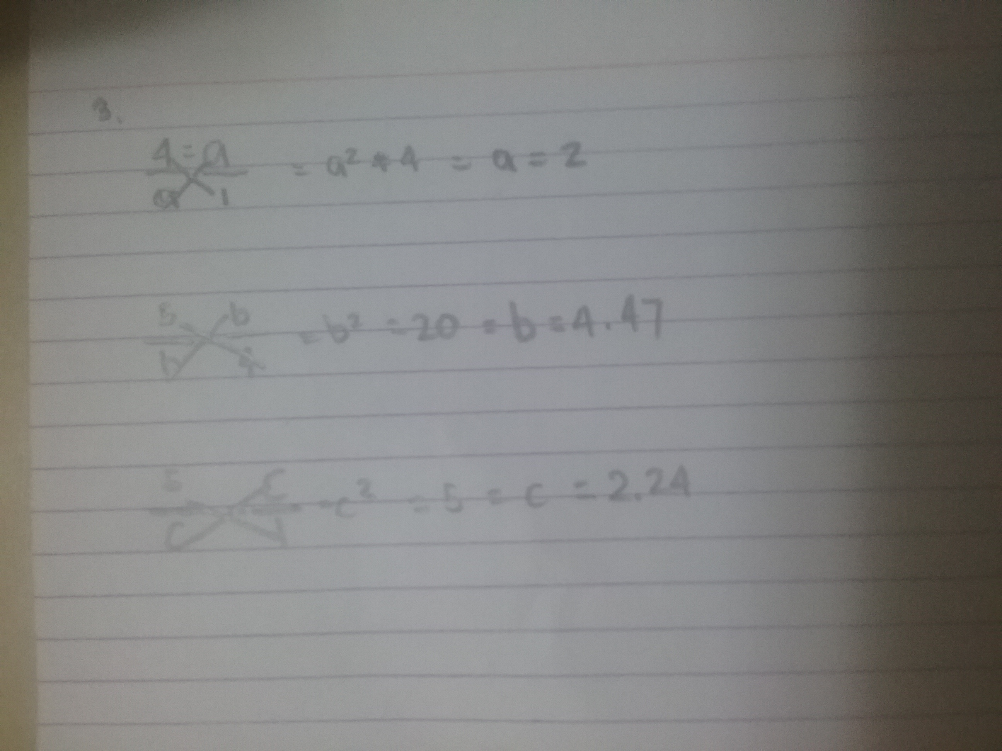

A = 2

B = 4.47

C = 2.24

III. Prove each of the following.

1. Two isosceles triangles are similar if a base angle of one is congruent to a base angle of the other.

Given: Isosceles triangle XYZ and Isosceles triangle QRS;

$m∠Z=m∠S$

Prove: $△XYZ∼△QRS$

X

Y

Z

Q

R

S

|  |  |
| --- | --- |
| STATEMENT | REASON |
| 1. Isosceles triangle XYZ and Isosceles triangle QRS; $m∠Z=m∠S$ | Given |
| 2. $m∠Z=m∠Y$ and $m∠S=m∠R$ | Definition of an Isosceles triangle |
| 3. $m∠Y=m∠R$ | TPE |
| 4. $m∠Z=m∠S$ | AA Theorem |